

**ZCLINIC WIREFRAME**

| Zewail City of Science and Technology Team 5  University of Science and Technology  Communications & Information Engineering Program  CIE 206 - Spring 2021  Database Management Systems  DataBase Project  Report title: GUI Wire frame  Team Number: 5  Team Members:  Omar El-Sakka  Noureldin Hamedo  Mariam Magdy Elseedawy  Contact info:  s-mariam.elseedawy@zewailcity.edu.eg  18/4/2021 |
| --- |

**The welcoming page is the (login page):**

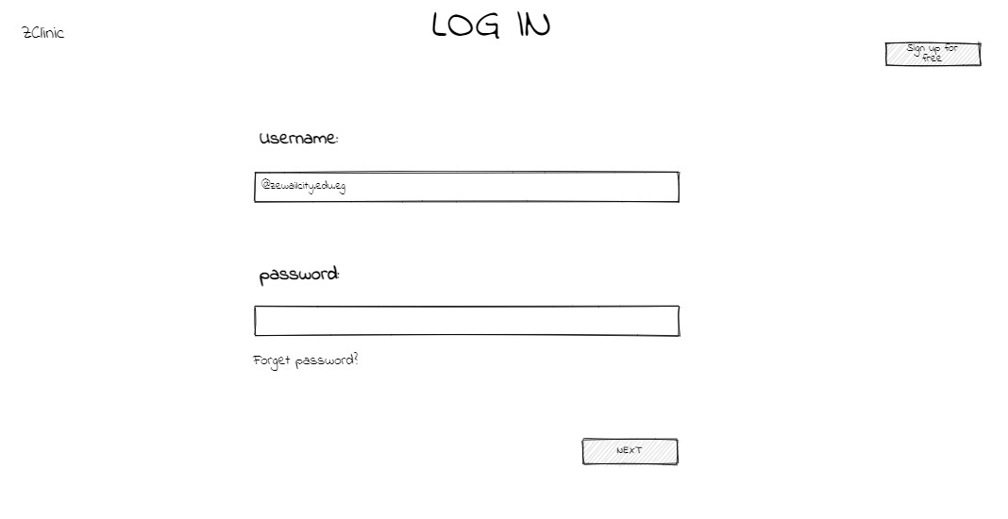

1) username is the email of the user.

2) if the user clicks on “forget password”, he will be asked about some questions. then the program will open if he answered correctly.

3) signup for free button will take the user to the sign up page.

**SignUp Page:**

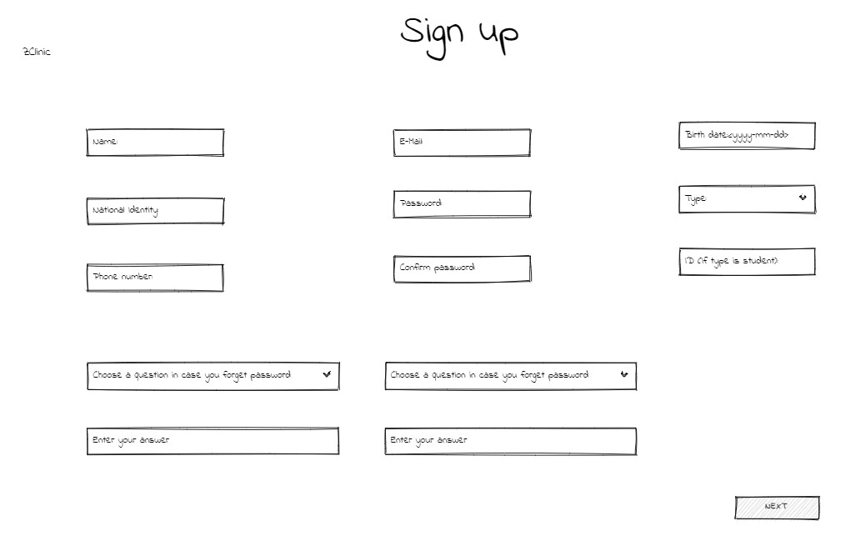

while user tends to sign up in our program, he would enter his:

1) Name

2) National Identity

3) phone number

4) E-mail

5) password & confirm password

6) birth date (yyyy- mm-dd)

7) type

8) ID of the student: This input field will be visible only if the type of the user is student.

9) the user chooses two question that the program would ask in case the user forget the password.

**“Medical info page”:**

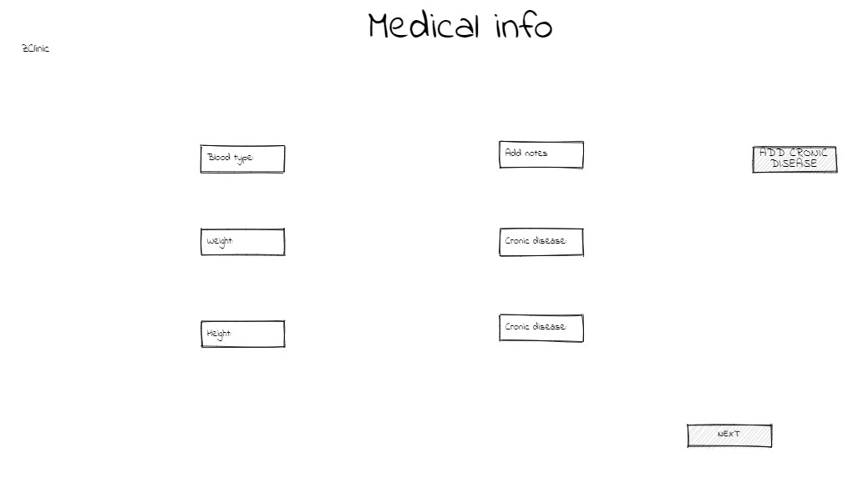

After signing up, the user has to enter some medical information like:

1) blood type

2) weight

3) height

4) add any notes (if the user feels that these note would help the doctor to diagnose).

5) write his chronic disease (If the user has more than one chronic disease he could use the button of ADD Chronic disease).

**Statistics page:**

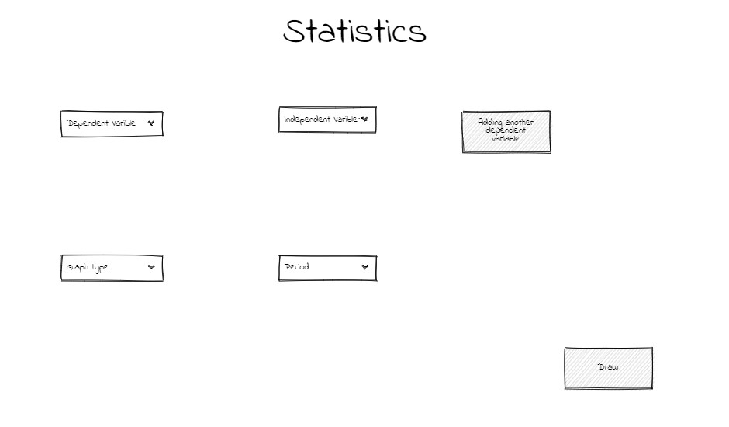

Statistics page: the clinic staff “Doctor” can use this page to make his own statistics by defining:

1) Dependent variable.

2) Independent variable(s).

3) Graph type (Pie chart, Histogram, scatter, or line plot)

4) period (the period that the doctor want to study).

**Before Login and sign up page, 1st page.**

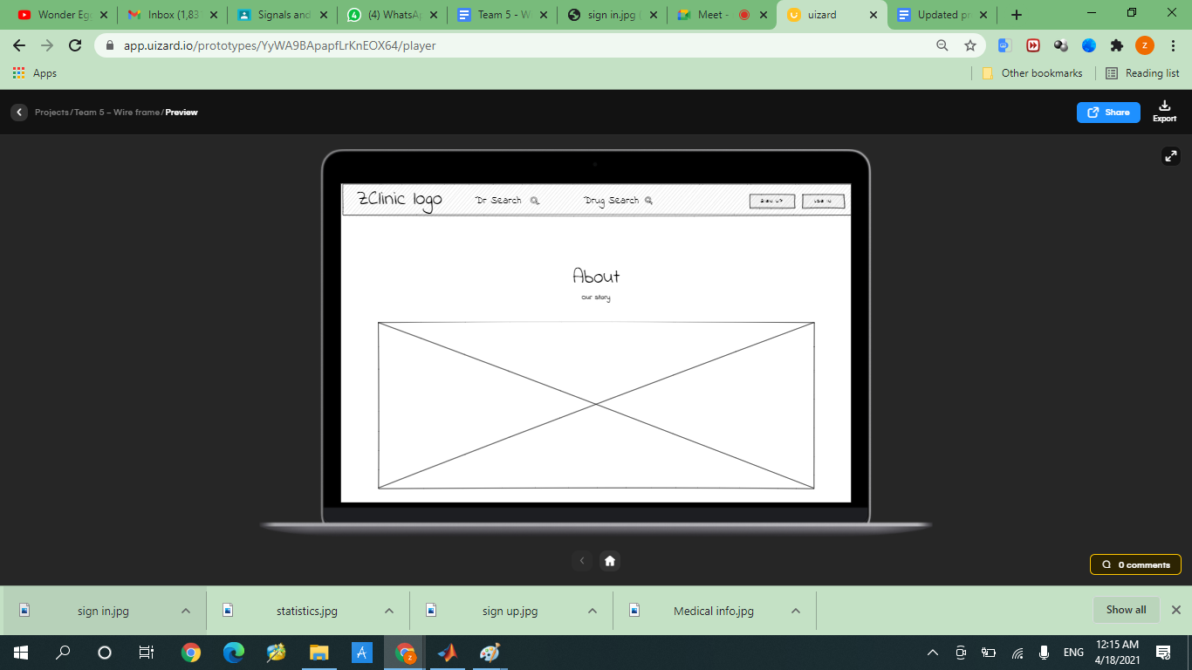

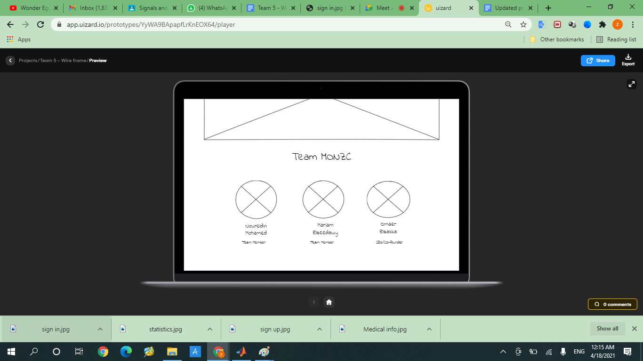

**Home Page:**

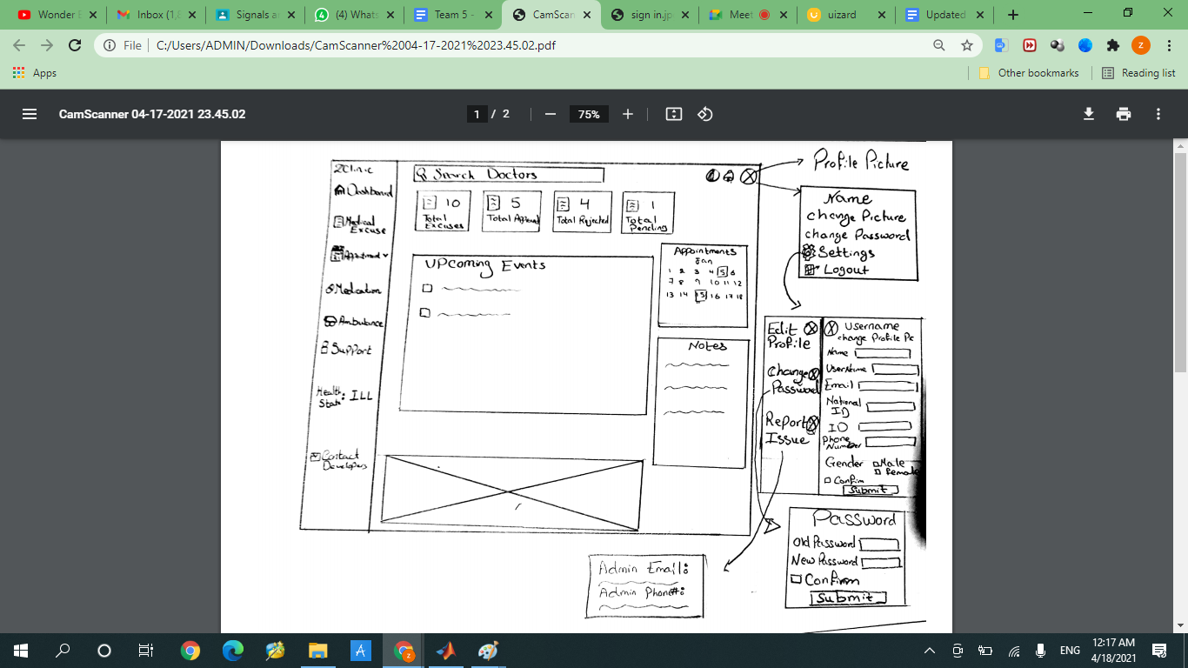

The bell beside the profile pic is notifications, and the icon beside the bell is dark and light mode button

**Medication Page and Loading Page:**

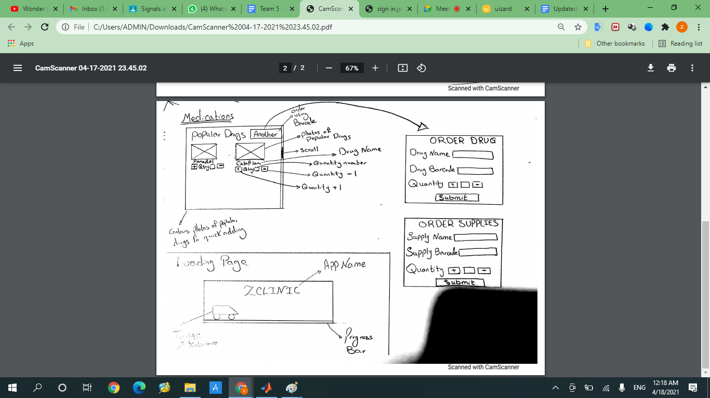

**Appointment Pages:**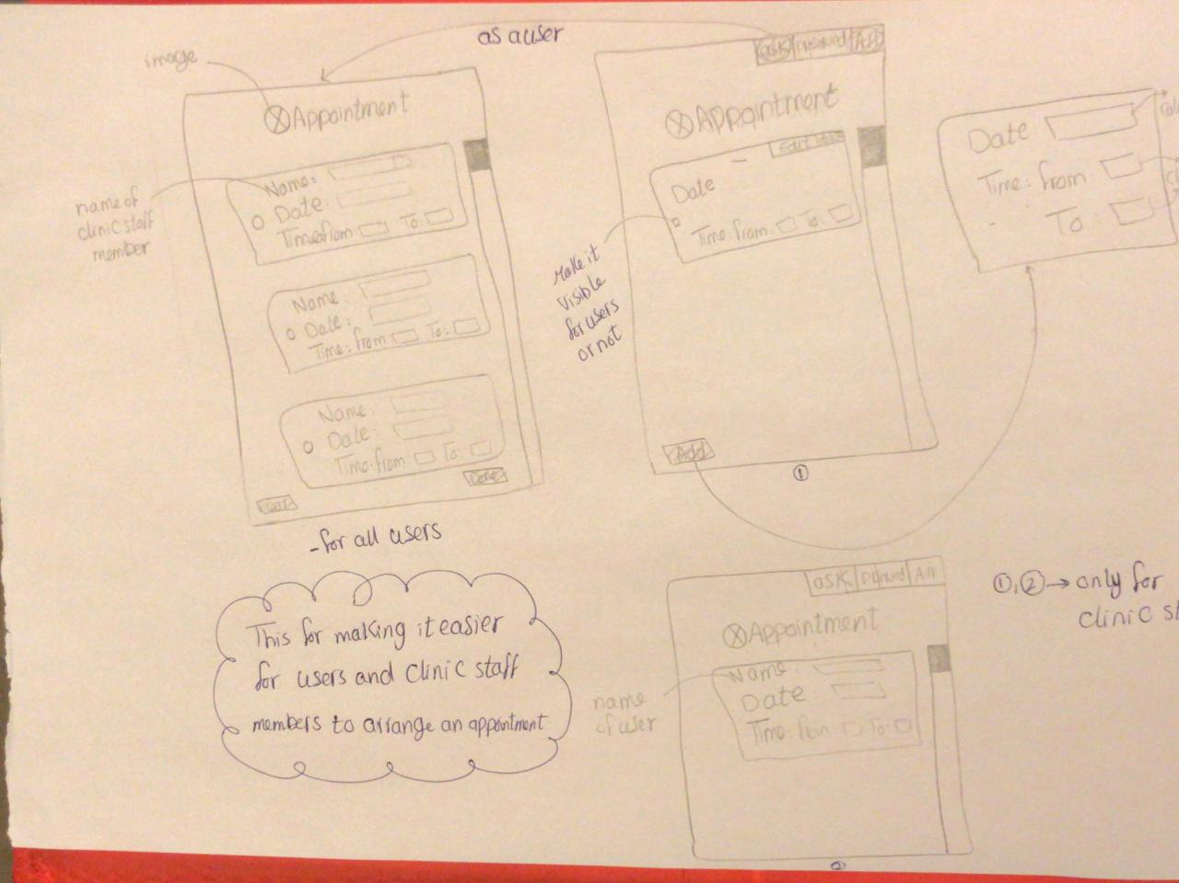

**Medical Excuse Pages:**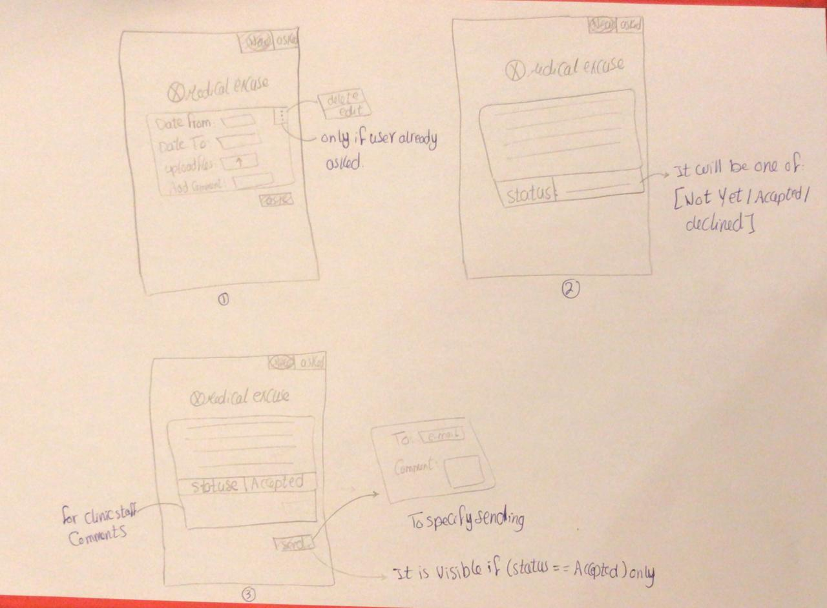

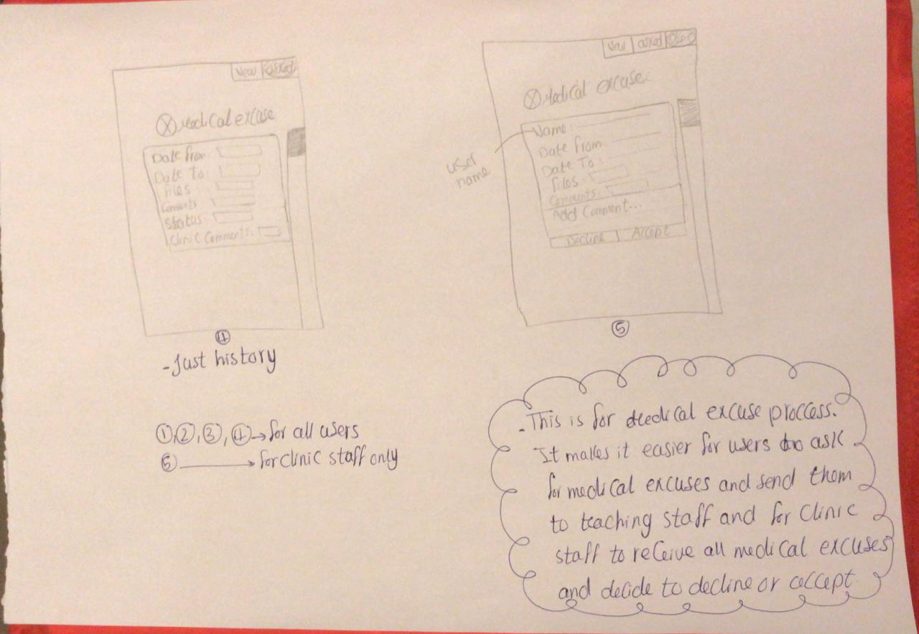

**Support Page:**

